**Practical No.07**

1. **Open firefox and click on extension search tamper data**

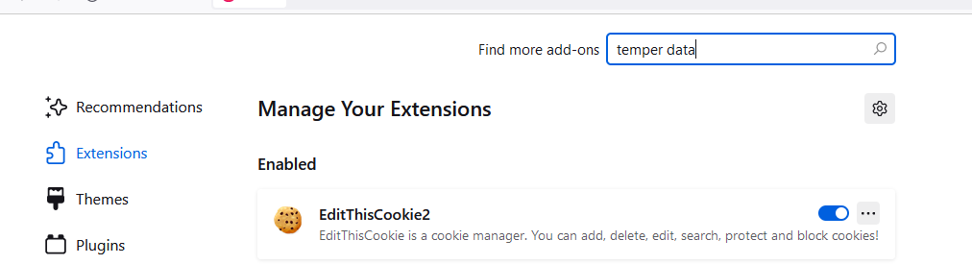

1. **Download temper data extension and click on yes button**

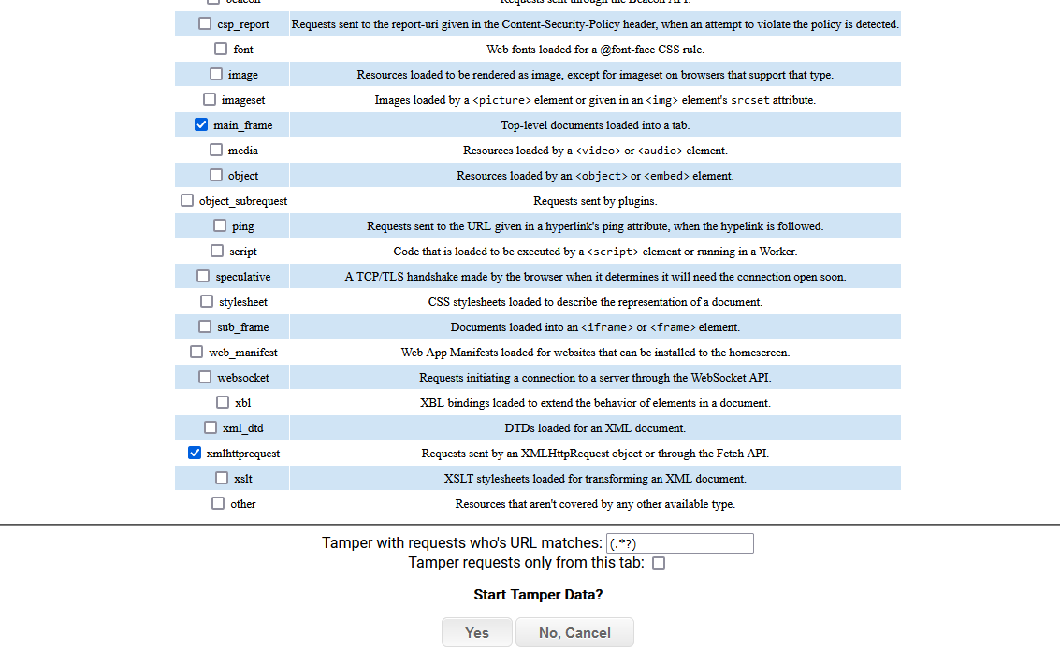

1. **Search** [**www.google.com**](http://www.google.com) **on browser**

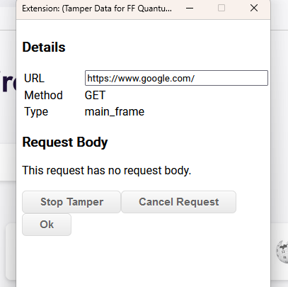

1. **Change the youtube.com replacing youtube.com and click on stop temper**

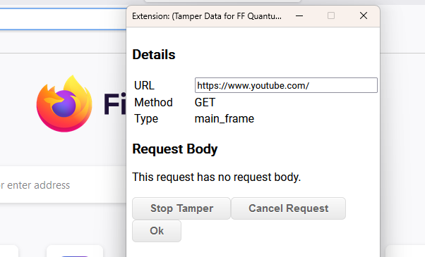

1. **Youtube website run on browser**

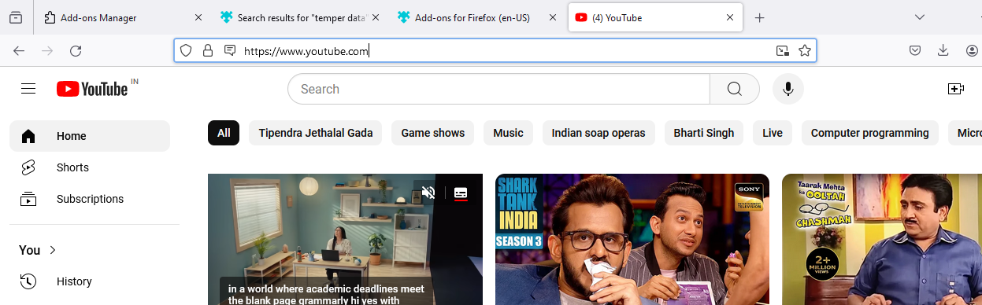

1. **Search mysmsmantra.com on browser and click on payment option and fill the details run tempar data extension and proceed the payment**

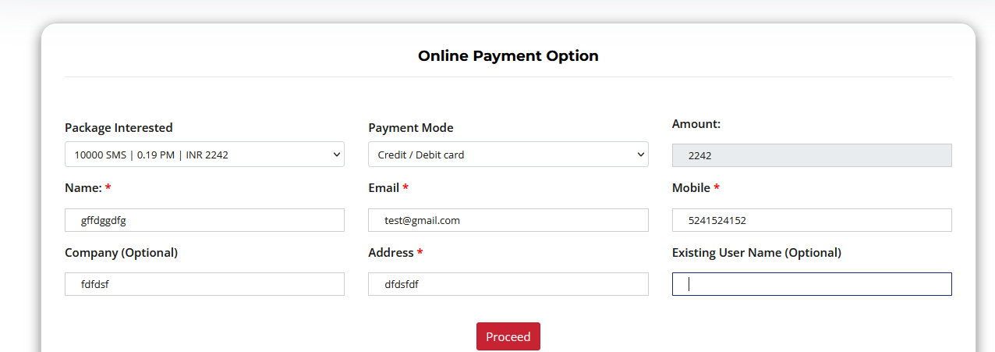

1. **Click on extension and proceed the details**

